**The Pokémon** **Reality Gear**

**Instruction Manual**

## **Table of Contents**

1. About Pokémon Reality Gear
2. Before using the Pokémon Reality Gear
3. Warnings
4. What’s inside the box?
5. Part names
6. Putting the headset on
7. Pokémon VR Gear functions
8. Calibration of the interpupillary distance/Calibration Slot
9. Connecting the headset to your computer
10. Cleaning the Headset and Lenses
11. Setting up the device ---
12. The Game ---
13. **About Pokémon Reality Gear**

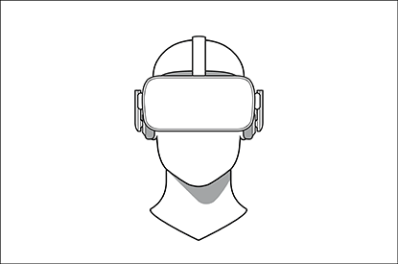The Pokémon Reality Gear is a virtual reality device that enables you to look and move around a virtual environment providing an immersive experience for all users. Once connected to a compatible device you can start playing Pokémon right away.

1. **Before using the Pokémon Reality Gear**

* Carefully read and follow all the instructions provided with the Pokémon Gear before using the product.
* Please read the warnings below before using the headset to reduce risk of injury or damage of the device.
* It is recommended to see a doctor if you are pregnant, elderly, or suffer from a mental illness or another medical condition.

1. **Warnings**

* The headset together with the game produce an immersive virtual reality, which is at times hard to differentiatefrom reality. To avoid possible accidents while playing Pokémon stay away from stairs, balconies, windows etc.
* Do not use the device for longer than 2 hours without breaks.
* Children under the age of 12 and psychologically unstable users must disable the Neuro-Stimulators.
* You can wear glasses inside the Gear, they should however be removed in case of discomfort. Keeping the glasses on while experiencing discomfort may cause facial injuries. Users with poor eyesight are recommended to wear contact lenses while wearing the Pokémon Gear.
* The Pokémon Gear can be affected by magnetic interference created by devices, such as computers or televisions. Avoid using the Gear in areas affected by magnetic interference.
* Direct sunlight pointed to the lenses of the headset may cause damage to the display. When not using the headset, make sure to store it with the lenses pointed away from direct sunlight.

1. **What’s inside the box?**

|  |  |
| --- | --- |
| Main Component | Accessories |
| Pokémon Headset | * Cable (attached) * Earphones (Attached) * Lenses (2) and cleaning cloth |
| Link Box | * Headset cable * USB cable |

1. 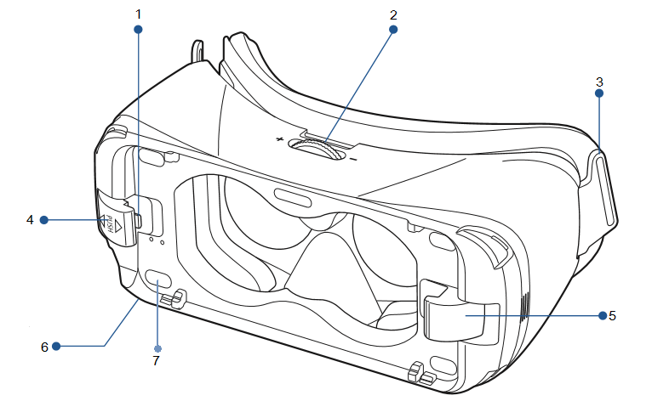**Part names**

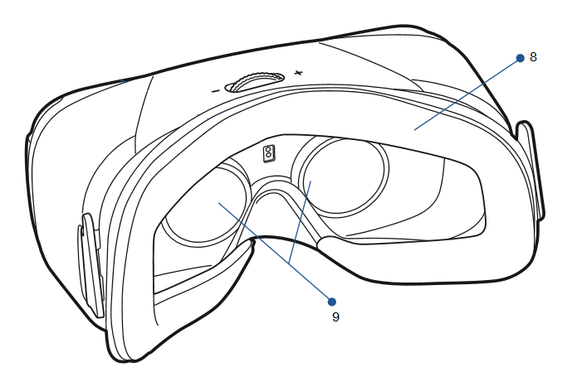

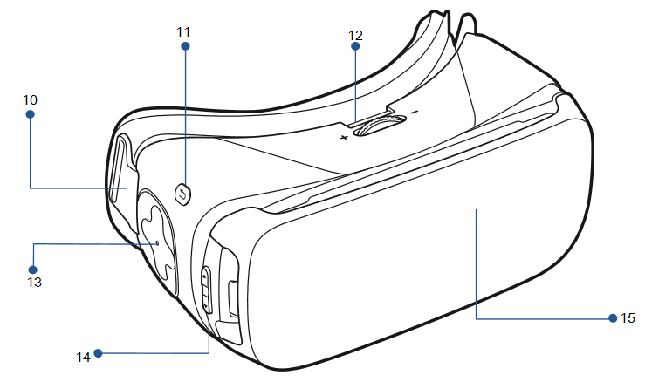

1. USB Connector
2. Calibration Slot
3. Tape
4. Left Neuro-Stimulator
5. Right Neuro-Stimulator
6. Charging Port
7. On/Off Button
8. Foam Cushioning
9. Lenses
10. Tap
11. Back Key
12. Calibration Slot
13. Touchpad
14. Volume Button
15. Front Cover
16. 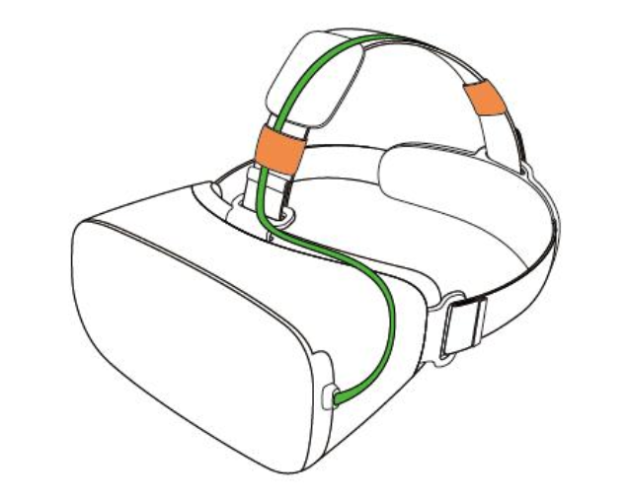**Putting the Headset on**

* The Pokémon Gear should be placed properly on your head during use.

1. Pull the headset down until your eyes are on the same level with the lenses.
2. Slide the head belt to the back of your head and fasten it so that it fits well. Make sure it is not too tight.
3. Afterwards regularly check the headset’s fit so that you feel well while playing.
4. **Pokémon VR Gear functions**

|  |  |
| --- | --- |
| Button | Function |
| On/Off | * Press to turn the headset on or off. |
| Back | * Press and hold to enter the main menu. * Press to return to the previous screen. |
| Volume Key | * Press + to turn the volume. * Press – to turn the volume down. |
| Calibration Slot | * Rotate to focus the view. |
| Touchpad | * Tap to select. * Swipe across to move around the screen. |
| Neuro-Stimulator On/Off | * Press the green button to turn the Neuro-Stimulators on. When turned on, the light of the button turns on. * Press the red button to turn the Neuro-Stimulators off. When turned off, the green light goes off. |

1. **Calibrating the interpupillary distance (IPD)**

Everyone has a differently shaped head. To have the best experience it is necessary that the shift in the game corresponds to the shift in the real world. That is why we must know your interpupillary distance. **Interpupillary distance (IPD)** is the distance between the center of the pupils of the two eyes. The Pokémon Gear has an attached Calibration function so that you can measure your IPD without the help of an optician. Follow the steps below after you have worn and turned the headset on.

* Using the Calibration function

1. Go to the main menu by pressing and holding the Back button. Tap “vr_calibration” and then Enter. The calibration screen will open and a piece of text will appear in front of you.
2. Start rotating the **Calibration Slot** (No. 2) so that the text in front of you is as sharp as possible.
3. Follow this procedure twice for both eyes.
4. After you have followed the procedure tap “OK”.
5. The measured IPD will automatically be saved for further use.

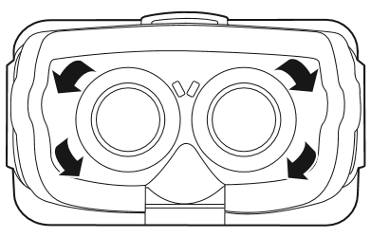

1. **Connecting the headset to your computer**
2. Unwrap the cables that come with the Pokémon VR Gear. There is a headset, USB and a power coble.
3. Plug the power cable into the charging port (No. 6) and then the other side of the cable to a power source.
4. Insert the USB cable on the right USB port of your computer.

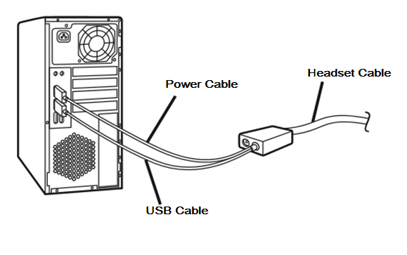

1. **Cleaning the Headset and Lenses**

**The Headset**

* Wet the cleaning cloth that comes in the package with water to wipe the headset and lenses clean. Do not use any other cleaning liquid. Other liquids may cause damage to the headset.
* The foam cushioning may get dirty if your face is sweating while wearing the Pokémon Virtual Reality Gear. This may harm the foam cushioning. Make sure that you keep your face and especially your forehead clean and dry while wearing the headset.

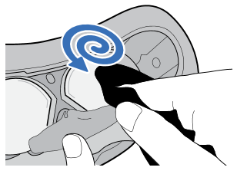**The Lenses**

* Use the same cleaning cloth provided in the package
* Wet the cloth with a lens cleaner or similar cleaning liquid.
* Wipe in circular motion without scratching the lenses.

1. **Setting up the device**

**…**